Chapter 3, Problem 17.

Using nodal analysis, find current i_{o} in the circuit of Fig. 3.66.
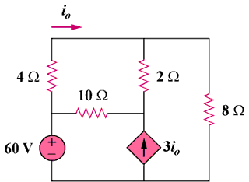

Figure 3.66
For Prob. 3.17.

